**Design Group Seven  
Brock Weekley,**

**Connor Travers,**

**Tristen Harr**  
**Project 2: Design Focus (team): Architecture and System Design Process: Fall 2019 CS4320/7320 Software Engineering**

|  |  |
| --- | --- |
| **Table of Contents** | |
| **Use Case Diagram** | **Page 3** |
| **Activity Diagram 1** | **Page 4** |
| **Activity Diagram 2** | **Page 5** |
| **Activity Diagram 3** | **Page 6** |
| **Class Diagram** | **Page 7** |
| **Entity Relations Diagram** | **Page 8** |
| **Sequence Diagram** | **Page 9** |
| **State Machine Diagram** | **Page 10** |

**Use Case Diagram:**

Created by Connor Travers

|  |
| --- |
| Title: Modify Assignment  Description: An instructor will modify the content of an assignment  Triggers: An instructor clicks on the 'edit assignment' button  Actors: Instructors  Preconditions: The Instructor must be logged in and the assignment must exist  Main Success Scenario: The instructor successfully updates assignment data  Failed End Condition: Assignment not successfully updated, user prompted with error message  Extensions:  User tries to modify nonexistent assignment   * User is prompted with an error message   User wishes to lock the assignment at due date   * System prompts a toggle switch for locking assignment at due date   Steps of Execution: Instructor selects an assignment, clicks on an "edit" button, updates assignment data, submits changes to update assignment database |

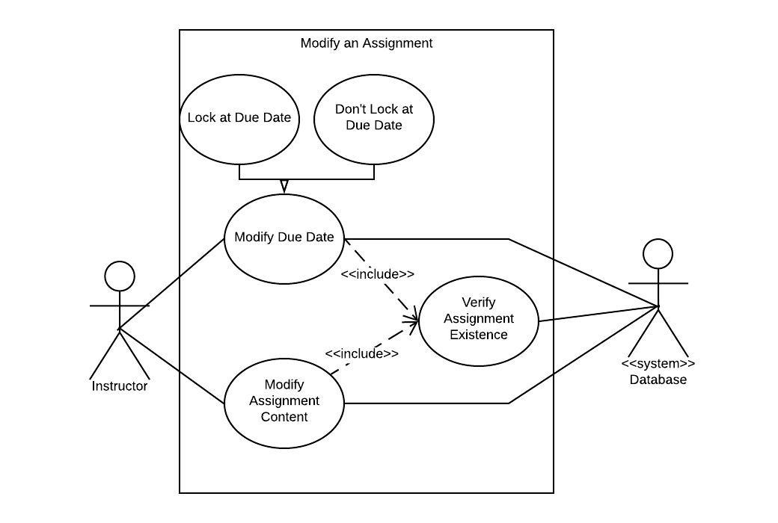

**Activity Diagram 1:**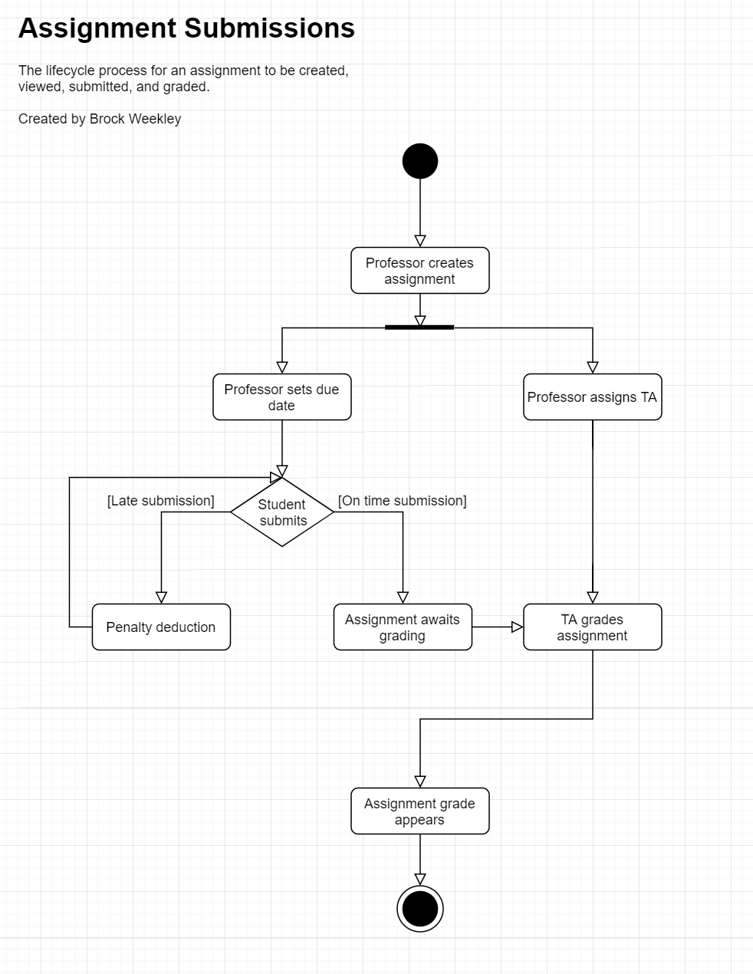

**Activity Diagram 2:**

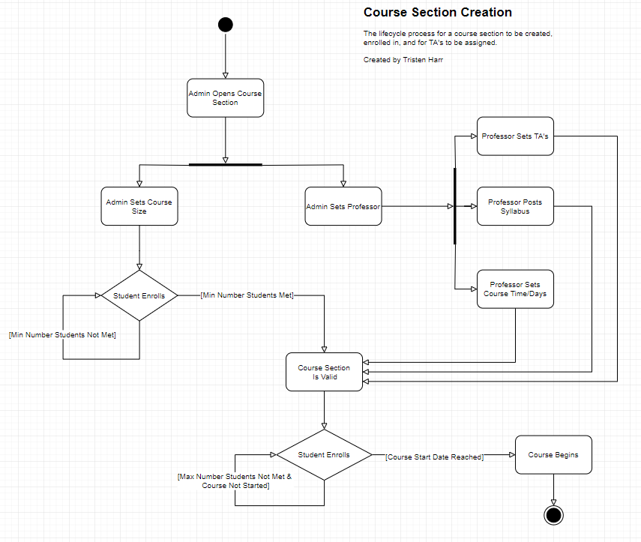

**Activity Diagram 3:**

**Instructor Modification**

The process of creating and modifying Instructors according to Admins.

Created by Connor Travers

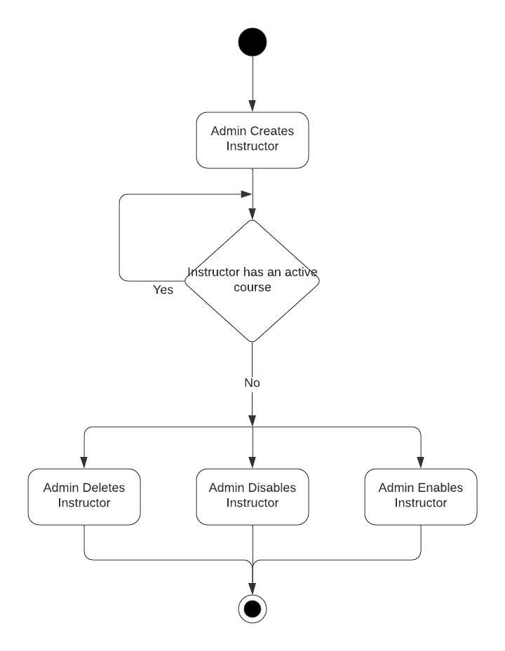

**Class Diagram:  
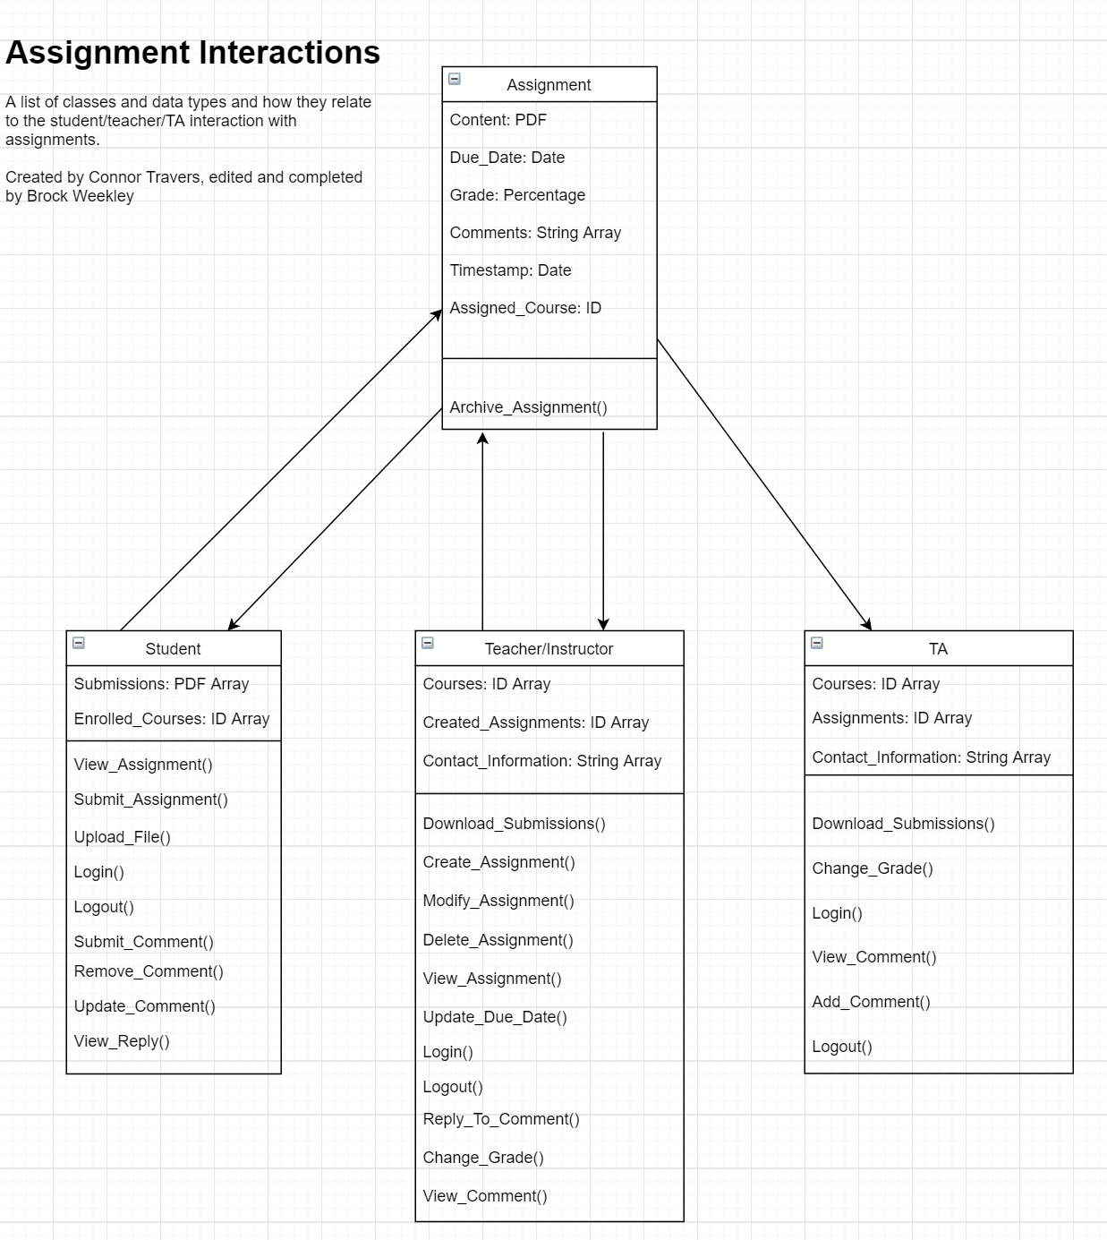**

**ERD**

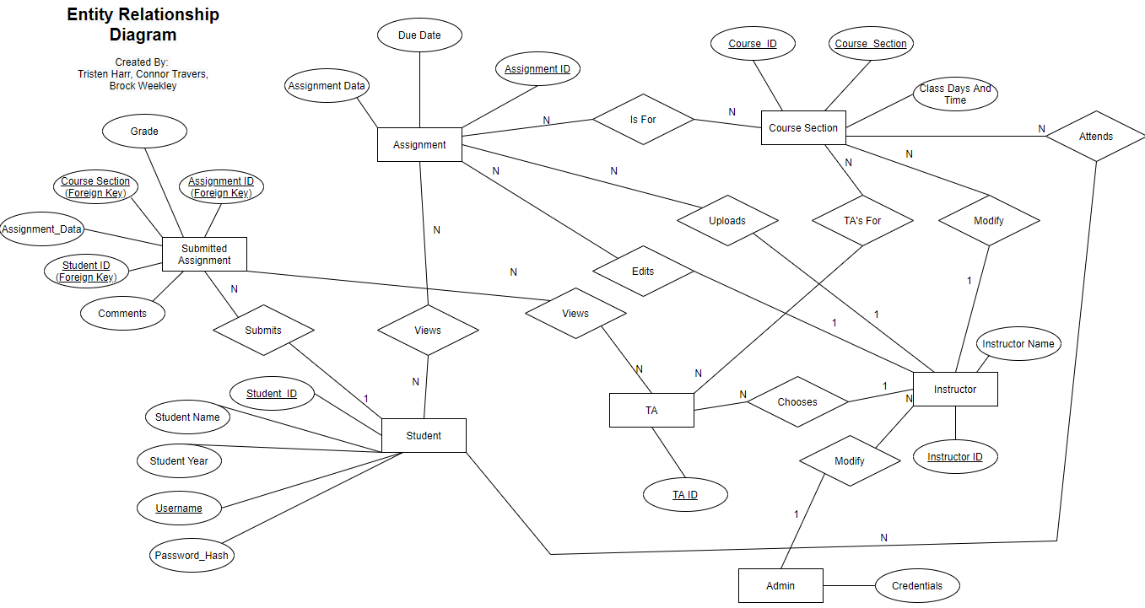

**Sequence Diagram:**

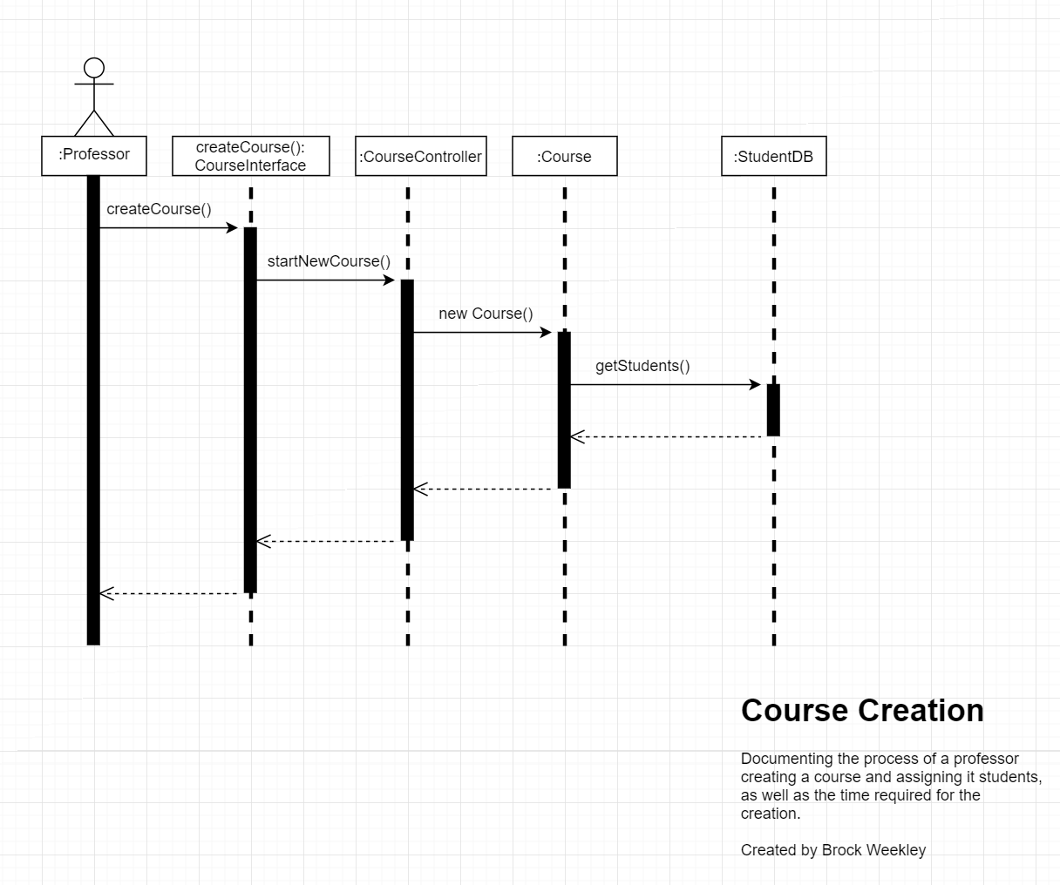

**State Machine**

